1. Categories of CCTV Cameras (Based on Technology)

a. Analog CCTV Systems
Description:
Analog CCTV cameras send video signals through cables (usually coaxial cables) to a Digital Video Recorder (DVR).
The DVR changes the video into a digital format for storage and viewing.
Example:
Old-style security cameras in banks or small shops often use analog systems.
Advantages:
- Cheaper to buy and install.
- Simple to set up.
- Works well for small buildings or homes.
Disadvantages:
- Lower image quality (not HD in most cases).
- Harder to view remotely (needs extra setup).
- Uses more cables and hardware.

b. IP CCTV Systems (Internet Protocol)
Description:
IP cameras send video data over a network or the internet to a Network Video Recorder (NVR).
They use Ethernet cables or Wi-Fi instead of analog cables.
Example:
Modern cameras you can view from your phone, like those in offices or smart homes, are IP cameras.
Advantages:
- High-quality images (HD or even 4K).
- Easy remote access (view from phone or computer).
- Can cover large areas using fewer cables (network-based).
- Can add many cameras easily.
Disadvantages:
- More expensive.
- Needs network setup knowledge.
- Uses more internet bandwidth.

Main Differences Between Analog and IP CCTV
Feature | Analog CCTV | IP CCTV
Image Quality | Low to Medium | High (HD/4K)
Connection | Coaxial cable | Ethernet/Wi-Fi
Storage | DVR | NVR
Remote Viewing | Limited | Easy
Cost | Cheaper | More expensive
Scalability | Harder to expand | Easy to expand

2. Based on Usage

a. Indoor CCTV Cameras
Description:
Used inside buildings — like offices, shops, and homes.
They’re not built to handle rain or harsh sunlight.
Example:
A small camera in a supermarket aisle or living room.
Advantages:
- Small and lightweight.
- Cheaper than outdoor cameras.
- Easy to install.
Disadvantages:
- Can’t survive outside weather conditions.
- Limited night vision sometimes.

b. Outdoor CCTV Cameras
Description:
Used outside buildings — designed to handle rain, sun, dust, and wind.
Usually have a strong metal casing and weatherproof design (IP65 or IP67 rated).
Example:
A camera on a street pole or building entrance.
Advantages:
- Weatherproof and durable.
- Better night vision.
- Can cover large outdoor areas.
Disadvantages:
- More expensive.
- Needs strong mounting.
- Requires more maintenance.

3. Based on Connectivity

a. Wired CCTV Systems
Description:
Cameras are connected to the recorder (DVR/NVR) using physical cables.
Example:
A shop with cameras connected to a central room by cables.
Advantages:
- Stable connection.
- No signal loss.
- Harder to hack.
Disadvantages:
- Takes time to install.
- Harder to move cameras later.
- Needs lots of cables.

b. Wireless CCTV Systems
Description:
Cameras send video using Wi-Fi or radio signals instead of cables.
Example:
A home camera that connects to your Wi-Fi and sends video to your phone.
Advantages:
- Easy to install (no cables).
- Can be placed anywhere with Wi-Fi.
- Easy to move around.
Disadvantages:
- May lose signal or lag if Wi-Fi is weak.
- Needs power (some still use cables for electricity).
- Easier to hack if not secured.

4. Based on Features

a. Day/Night CCTV Systems
Description:
Can work in both daylight and at night using infrared (IR) lights.
Example:
A camera outside a house that records clear video even in total darkness.
Advantages:
- Works 24/7.
- Automatically switches between day and night modes.
- Great for outdoor security.
Disadvantages:
- IR range is limited.
- Can attract insects at night (near IR lights).

b. PTZ (Pan-Tilt-Zoom) Cameras
Description:
Can move left-right (pan), up-down (tilt), and zoom in/out.
Controlled manually or automatically.
Example:
A camera in a shopping mall that moves to follow people or zooms in on certain areas.
Advantages:
- Covers large areas.
- Reduces the number of cameras needed.
- Great for live monitoring.
Disadvantages:
- More expensive.
- Needs an operator or software to control movement.
- Moving parts may wear out over time.

🎥 Does a PTZ Camera Rotate 360°?
✅ Yes — most PTZ cameras can rotate 360 degrees horizontally,
but there are a few details to understand:

🔄 1. Horizontal Movement (Pan)
- “P” in PTZ means Pan — turning left and right.
- Most PTZ cameras can pan a full 360°, and some can even spin endlessly (continuously 360°) without stopping.
- This allows the camera to watch in all directions around it.
Example:
A PTZ camera on a pole in a parking lot can rotate around and see every corner — cars entering, people walking, etc.

⬆️⬇️ 2. Vertical Movement (Tilt)
- “T” means Tilt — moving up and down.
- PTZ cameras can usually tilt from about 90° up to 180°, depending on the model.
- This means they can look almost directly above or below themselves.

🔍 3. Zoom
- “Z” means Zoom — the camera can zoom in and out.
- Some PTZ cameras have optical zoom (like 10×, 20×, 30×) to focus clearly on faraway objects — like a car plate 100 meters away.

⚠️ Note:
- Not every PTZ camera can rotate continuously 360°.
Some cheaper ones rotate up to 355° and stop — they must turn back the other way.
- High-end PTZ cameras (used in city surveillance or stadiums) can spin endlessly in 360° mode.

c. HD (High Definition) CCTV Systems
Description:
Provide very clear, high-resolution video (720p, 1080p, 4K).
Can be either analog (HD-over-coax) or IP.
Example:
A high-resolution camera in a bank that can show clear facial details.
Advantages:
- Clearer video and better identification.
- Useful for investigations.
- Professional look.
Disadvantages:
- Uses more storage space.
- Needs better network and equipment.
- Higher cost.
✅ Summary Table
Category | Type | Example Use | Key Advantage
Technology | Analog | Small shop | Cheap and simple
Technology | IP | Office, smart home | High quality & remote access
Usage | Indoor | Office room | Cheap and neat
Usage | Outdoor | Parking lot | Weatherproof
Connectivity | Wired | Factory | Stable connection
Connectivity | Wireless | Apartment | Easy to install
Feature | Day/Night | Street | Works 24/7
Feature | PTZ | Mall | Moves & zooms
Feature | HD | Bank | Clear images

🖥️ What is Resolution (720p, 1080p, 4K)?
Resolution means how clear or detailed an image or video looks.
It depends on how many tiny dots (called pixels) make up the picture.
➡️ The more pixels there are, the clearer and sharper the image looks.

🧩 Think of it like this:
Imagine a photo made of small tiles.
- If you use few big tiles, the picture looks blurry (low resolution).
- If you use many small tiles, the picture looks clear and detailed (high resolution).
Pixels = those tiny tiles.

📊 Common CCTV Resolutions
Resolution | Full Name | Pixels (Width × Height) | Nickname | What it Looks Like
720p | HD (High Definition) | 1280 × 720 | "HD" | Clear but not very sharp. Good for small rooms.
1080p | Full HD | 1920 × 1080 | "Full HD" | Very clear. Good for most CCTV uses (shops, offices).
4K | Ultra HD | 3840 × 2160 | "Ultra HD" | Super clear — shows faces and details even from far away.
8K | Super Ultra HD | 7680 × 4320 | "8K" | Extremely detailed (rare in CCTV, mostly for movies).

👀 Real-life Examples
- 720p: Like watching a YouTube video on “medium quality.” You can see people, but not clear faces from far away.
- 1080p: Like watching a modern TV show — clear enough to recognize faces.
- 4K: Like a high-end smart TV — you can zoom in and still see small details, like a car’s number plate or facial features.

⚖️ Advantages of Higher Resolution (like 4K):
✅ Sharper images and more details.
✅ Easier to identify faces, license plates, or small objects.
✅ Looks good even when zooming in.
Disadvantages:
❌ Needs more storage space (video files are bigger).
❌ Uses more internet bandwidth for remote viewing.
❌ More expensive cameras and recorders.

🏁 In Short:
Type | Quality | Best Use
720p | Basic | Small rooms or homes
1080p | Good | Shops, offices
4K | Excellent | Banks, parking lots, city cameras

TYPES OF CAMERAS
📷 What is a Camera Lens?
A lens is the “eye” of the camera.
It’s the glass part in front that collects light and focuses it onto the camera’s sensor to create an image.
Just like your eyes help you see, the lens helps the camera see.
👀 Simple Example:
When you wear eyeglasses, they help you see clearly —
👉 the camera lens does the same thing for a CCTV camera.
If the lens is good, the camera sees clearly and in detail.
If it’s poor or not focused, the image looks blurry.
🔍 Main Functions of a Lens:
- Focuses light:
It brings the picture into sharp focus, so you can see faces or objects clearly.
- Controls how far or near the camera sees:
Some lenses show a wide area (but less detail),
others show a narrow area (but more detail).
- Affects image brightness and clarity:
Lenses with a large opening (called aperture) let in more light — good for night vision.
⚙️ Types of Lenses (in CCTV cameras):
Type | Description | Example
Fixed Lens | Cannot zoom or change view; shows one set area. | A simple indoor shop camera.
Varifocal Lens | Can manually adjust zoom and focus. | Used where you need to fine-tune view, like at a gate.
Motorized Zoom Lens | Zooms in/out using a remote or software. | Found in PTZ cameras or smart IP cameras.
🎯 Lens Size (Focal Length)
The lens has a number like 2.8mm, 4mm, 6mm, 12mm, etc.
This is called focal length, and it decides how wide or narrow the camera sees:
Focal Length | What it Means | What You See
2.8mm | Wide angle | Covers a large area, but less detail (like an entire room).
4mm–6mm | Medium angle | Normal viewing (like a gate or small parking lot).
12mm+ | Narrow angle | Zoomed-in view — good for faraway objects.

👁️ Example to Remember:
- 2.8mm lens: like using your phone’s wide selfie camera — you see more of the background.
- 12mm lens: like using binoculars — you see far, but less around you.

🎯 1. Bullet Cameras
Description:
Bullet cameras are long and cylinder-shaped, like a “bullet” or a small tube.
They are usually fixed (pointing in one direction) and mounted on walls or poles.
Example:
The camera you often see on a shop’s outside wall, pointing toward the gate or parking area.
Main Uses:
- Outdoor monitoring (gates, roads, car parks, building entrances).
Advantages:
- Long viewing range — can see far distances.
- Easy to notice — acts as a visible warning to criminals.
- Weatherproof (for outdoor models).
Disadvantages:
- Can be tampered with easily since they are visible.
- Not good for discreet monitoring.
🏠 2. Dome Cameras
Description:
Dome cameras are small, round, and placed inside a glass dome cover.
They’re often installed on ceilings.
Example:
Cameras you see inside supermarkets or offices that look like half-spheres.
Main Uses:
- Indoor areas (shops, hotels, offices, schools).
Advantages:
- Hard for people to tell which way the camera is facing.
- Looks neat and blends with the ceiling.
- Usually has a wide viewing angle for covering large rooms.
Disadvantages:
- Some are not suitable for outdoor use (unless weatherproof).
- Harder to adjust the lens direction after installation.
🎮 3. PTZ Cameras (Pan-Tilt-Zoom Cameras)
Description:
PTZ stands for Pan (move left-right), Tilt (move up-down), and Zoom (in-out).
These cameras can move automatically or be controlled remotely.
Example:
Used in stadiums, city surveillance, and malls — the camera follows people or vehicles.
Main Uses:
- Large areas (parking lots, city streets, factories).
Advantages:
- One PTZ camera can cover many directions.
- Zooms in for close details.
- Can be controlled manually or set to move automatically (patrol mode).
Disadvantages:
- More expensive.
- Needs a skilled operator or software.
- Moving parts may wear out over time.
📦 4. Box Cameras
Description:
Box cameras look like small rectangular boxes with a lens on one side.
You can change the lens type depending on how far you want to see.
Example:
Used in banks or government buildings where customized lenses are needed for special viewing.
Main Uses:
- Professional surveillance where specific lens options are needed (like focusing on an ATM or long hallway).
Advantages:
- Very flexible — you can choose lenses for short or long distances.
- Good image quality.
- Works well indoors (can also be placed in weatherproof housings for outdoor use).
Disadvantages:
- Large and not good-looking.
- Needs a separate housing for outdoor protection.
- Can be noticed easily.
🌡️ 5. Thermal Cameras
Description:
Thermal cameras see heat instead of light.
They detect temperature differences and show images in colors like red, yellow, and blue — depending on the heat.
Example:
Used by police or security guards at night to see people hiding in bushes or dark areas.
Also used in airports to check people’s body temperature (e.g., during COVID-19).
Main Uses:
- Night security (even in complete darkness).
- Detecting intruders or fire.
- Industrial and military use.
Advantages:
- Works even in total darkness, fog, or smoke.
- Detects hidden objects or people.
- Excellent for perimeter and outdoor surveillance.
Disadvantages:
- Very expensive.
- Doesn’t show clear facial details (only heat shapes).
- Needs special software for best results.
🚗 6. License Plate Reader (LPR) Cameras
Description:
LPR (License Plate Recognition) cameras are designed to capture and read vehicle number plates clearly, even when cars are moving fast or at night.
Example:
Used at toll gates, parking entrances, and police road checkpoints.
Main Uses:
- Traffic monitoring.
- Parking management systems.
- Security access gates (to allow or deny entry).
Advantages:
- Can read number plates day or night.
- Works even with fast-moving cars.
- Helps in crime investigation and traffic control.
Disadvantages:
- Expensive.
- Needs good lighting and correct installation angle.
- May have issues with dirty or damaged plates.

LEARNING OUTCOME 2: DEPLOY CCTV EQUIPMENT
1. Selection of Tools, Materials and Equipment for CCTV Installation

A. Definitions and Differences

1. Tools
- Definition: Hand-held or powered instruments used to perform specific tasks during installation.
- Purpose: To cut, drill, fix, test and prepare installation surfaces and components.
- Example: Screwdriver, drill, cutter.

2. Materials
- Definition: Consumable items used during installation that become part of the CCTV system or support it.
- Purpose: They assist in connecting, protecting, labeling, and organizing cables and devices.
- Example: Cables, pipes, screws, cable ties.

3. Equipment
- Definition: Main electronic devices used to operate, display, store, or transmit CCTV video.
- Purpose: They form the actual CCTV system for recording, monitoring, and powering the cameras.
- Example: Cameras, NVR, monitor, power supply.

Difference Summary
Category | Description | Consumption | Examples
Tools | Used to perform tasks | Do not remain in installation | Drill, screwdriver
Materials | Items used up or installed permanently | Consumed or fixed | Cables, screws
Equipment | Main operational devices | Remain in system | Camera, NVR

B. Types of Tools

1. Cutting Tools
Used to cut cables, pipes, plastic trunks.
Examples: Cable cutter, hacksaw, scissors, knife.

2. Drilling Tools
Used to make holes for mounting cameras or passing cables.
Examples: Electric drill, drill bits (Masonry, Steel, Wood bits).

3. Fixing Tools
Used to tighten, fasten, and secure devices.
Examples: Screwdrivers, spanners, hammer.

4. Patching Tools
Used to prepare network connections.
Examples: Crimping tool, RJ45 connectors, punch-down tool.

5. Testing Tools
Used to check if cables, cameras, and network are working.
Examples: Multimeter, cable tester, CCTV tester monitor.

C. Equipment Used in CCTV Installation
- Computer – used to configure the cameras and NVR.
- Monitor – displays live video or recorded footage.
- Power Supply – powers cameras and accessories.
- Switch (Network Switch) – connects multiple IP cameras in an NVR system.
- Storage Devices – HDD, SSD used to save recordings.
- Cameras – capture video footage (IP or Analog).
- Recording Devices – NVR (for IP cameras) or DVR (for analog cameras).

D. Materials Used in CCTV Installation
- Internet Bundles – for remote viewing.
- Connections – RJ45 connectors, BNC connectors, DC connectors.
- Cable Ties – organize and tie cables neatly.
- Cable Trunks – protect and hide cables.
- Pipes (Conduits) – protect cables in built-in or underground installations.
- Screws – fix mount brackets and devices.
- Wall Mounts – hold cameras or monitors in position.
- Power Extension – provides power outlets.
- Labelling Tags – used to identify cables.
- CCTV Power Supply Box – centralized power distribution to cameras.

1. Conducting CCTV Trunking

1.1 Description of Installation Types

A. Visible Trunking
Definition:
Visible trunking is trunking installed on the surface of walls or ceilings, where it is clearly seen.
Where used:
- Inside offices, schools, homes, shops.
- When drilling or wall-chasing is not allowed.
Advantages:
- Easy to inspect and maintain.
- Simple and quick to install.
- Low cost.
Example:
Running white PVC trunking along a corridor wall to supply cables for dome cameras.

B. Built-in Trunking (Concealed)
Definition:
Trunking installed inside the wall, usually during construction. It is completely hidden.
Where used:
- New buildings.
- High-end homes and hotels where aesthetics matter.
Advantages:
- Very neat and invisible.
- Protects cables from tampering.
Example:
Concealing trunking in a brick wall before plastering to pass RG59 coaxial cable for CCTV.

C. Semi Built-in Trunking
Definition:
Partly inside the wall and partly visible. Some sections may be embedded while others run outside.
Where used:
- Renovated buildings.
- When only part of the trunking can be hidden.
Advantages:
- Looks neater than fully visible trunking.
- Reduces cost compared to fully concealed installation.
Example:
Horizontal trunking hidden inside the wall while vertical drops remain visible.

D. Waterproof Trunking
Definition:
Trunking designed to resist water, rain, moisture, and corrosive conditions.
Where used:
- Outdoor CCTV installations.
- Car parks, construction sites, factories, coastal areas.
Advantages:
- Prevents water damage to cables.
- Increases lifespan of CCTV system.
Example:
Using waterproof PVC or IP65-rated trunking for cameras installed on a building’s exterior.

E. Underground Trunking
Definition:
Trunking installed below ground in trenches, usually using heavy-duty or armored conduits.
Where used:
- Large compounds
- Street surveillance
- Inter-building CCTV connections
Advantages:
- Safest from vandalism and tampering.
- Protects cables from weather.
Example:
Laying HDPE conduit underground to connect CCTV poles around the perimeter fence.

2. Identification of Trunking Material Types

A. Plastic Trunking (PVC)
Description: Made of polyvinyl chloride, lightweight and common.
Advantages:
- Cheap
- Easy to cut and install
- Doesn’t rust
- Available in many sizes
Example:
White PVC trunking used for indoor CCTV wiring in offices.
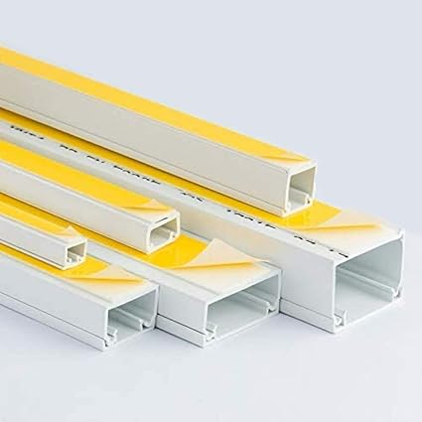

B. Stainless Steel Trunking
Description: Strong, metallic trunking made for heavy-duty protection.
Advantages:
- Strong and durable
- Fire-resistant
- Ideal for industrial or outdoor use
Example:
Stainless steel trunking used in factories to protect CCTV camera cables from impact.
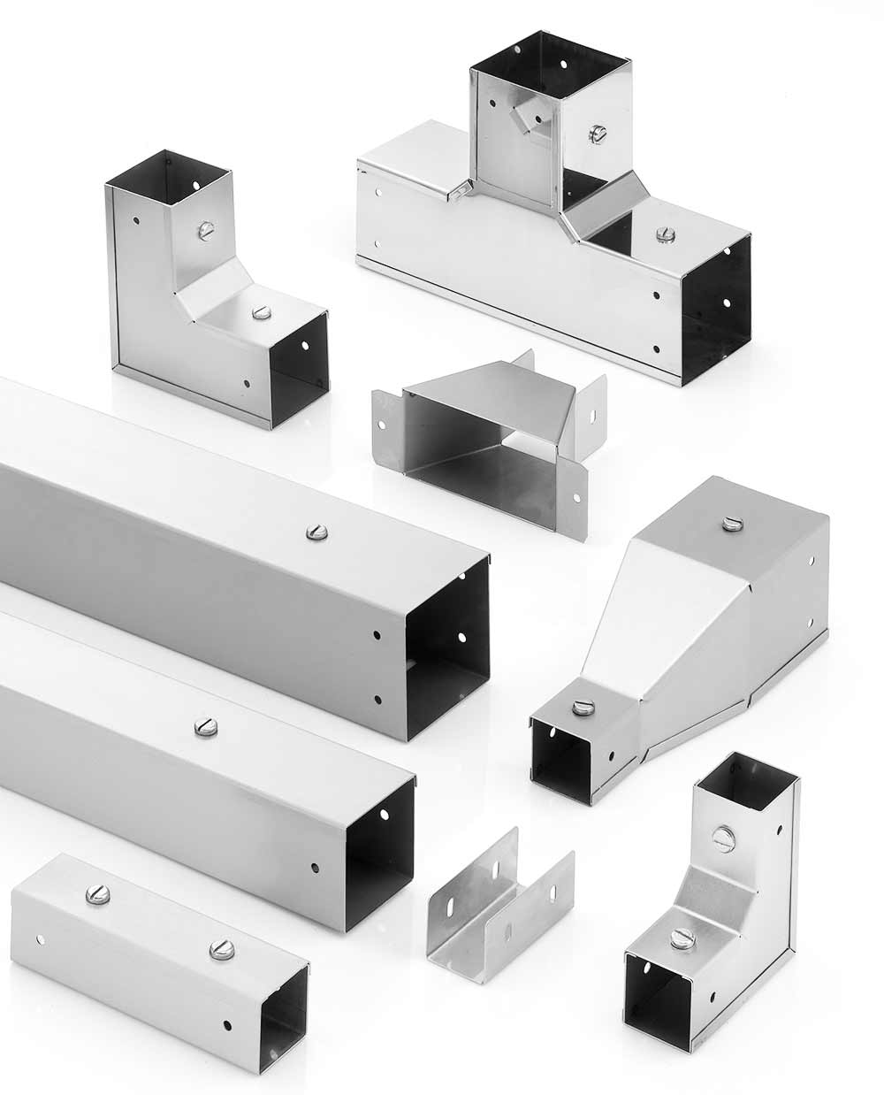

C. Wooden Trunking
Description: Trunking made from wood, mostly used for decorative or temporary installations.
Advantages:
- Matches wooden interior décor
- Low cost in rural settings
- Easy to fabricate on-site
Example:
Wooden cable casing installed inside a traditional wooden house for neat CCTV wiring.


3. Application of Cable Laying and Pulling

1. Cable Laying
Definition:
Cable laying is the process of positioning or arranging cables along a planned route—inside trunking, conduits, ducts, ceiling trays, underground trenches, or walls.
Focus:
- Planning the route
- Placing cables in their final position
- Arranging them neatly
What it involves:
- Measuring distances
- Deciding where cables will pass
- Installing trunking or conduits
- Placing cables in the trunking
- Arranging cables (parallel, bundled, stacked)
Example:
Laying CCTV coaxial cable inside PVC trunking installed along the wall.
Key Point:
Cable laying is about the placement and arrangement of the cable in its final path.

2. Cable Pulling
Definition:
Cable pulling is the action of physically pulling or drawing cable through a conduit, pipe, or duct using tools such as fish tape, pulling rope, or cable rods.
Focus:
- Moving the cable from one end to another
- Overcoming friction or obstacles inside conduits
- Avoiding damage to the cable during pulling
What it involves:
- Using pulling tools
- Applying pulling tension
- Applying lubrication if conduit is long or tight
- Pulling cable through underground or concealed conduits
Example:
Using fish tape to pull Cat6 cable through a 20-meter conduit from one office to the server room.
Key Point:
Cable pulling is about the action of moving the cable through a closed path (like conduit or pipe).

3.1 General Method
Steps:
- Measure distance between CCTV devices and control room.
- Select correct cable (RG59, Cat6, power cable, etc.).
- Install trunking or conduits along the planned route.
- Use fish tape or cable rods to pull cables through.
- Label both ends of the cables.
- Test continuity and signal before termination.
- Terminate connectors (BNC, RJ45, power jacks).
Example:
Using fish tape to pull Cat6 cable for an IP camera from the ceiling to the server room.

3.2 Cable Laying Arrangements
These describe how cables should be organized inside trunking.

A. Parallel Arrangement
Cables run side by side in a straight line.
Advantages:
- Neat
- Reduces tangling
- Makes future maintenance faster
Example:
Laying 4 Cat6 cables neatly side by side along a 50mm trunking.

B. Bundled Arrangement
Cables tied together in groups using cable ties.
Advantages:
- Easy to pull long distances
- Better management in crowded ducts
Example:
Bundling eight CCTV power cables together using Velcro straps.

C. Stacked Arrangement
Cables layered on top of each other inside a deep conduit.
Where used:
- When trunking is narrow but deep.
Example:
Stacking CCTV coaxial cables inside a 100mm underground conduit.

3.3 Segregation of Cables
Definition:
Keeping different types of cables separated to avoid electrical interference, fire hazards, and signal loss.
Why needed:
- Data cables (Cat6) are sensitive to interference.
- Power cables cause electromagnetic noise.
- Fire safety regulations require separation.

Examples of Segregation:
- Keep CCTV signal cables separate from 240V power cables.
- Use separate compartments inside trunking.
- In underground ducts, use different conduits for power and data.

Advantages:
- Improved video quality.
- Reduced noise and interference.
- Increased safety.
ELS10 – ASSEMBLING & CONNECTING CCTV SYSTEMS

1. Assembling CCTV Equipment
1.1 Rack Mount
Definition:
A rack mount is a metal frame used to organize and hold CCTV equipment such as NVRs, switches, power supplies, and patch panels in one place.
Why used:
- Keeps equipment neat and secure
- Improves airflow and cooling
- Prevents accidental damage
- Makes maintenance easier
Common rack items:
- DVR/NVR
- Network switch
- Power distribution units
- Patch panels
- UPS (backup power)
Example:
Mounting a 4U NVR and an 8-port PoE switch on a 12U network rack in a server room.

1.2 Camera Assembly
CCTV cameras must be prepared before installation.
Steps include:
- Attach the camera bracket or pole mount.
- Insert memory card (for standalone cameras).
- Fix camera lens cover.
- Adjust field of view (FOV).
- Test power and video signal using handheld tester.
Camera types assembled:
- Dome Cameras
- Bullet Cameras
- PTZ Cameras
- IP Cameras
- Analog Cameras (Coaxial)
Example:
Assembling a dome camera by fixing its base, inserting screws, and connecting Cat6 + power.

1.3 Recording Devices (NVR/DVR)
DVR – Digital Video Recorder
- Used with analog cameras (coaxial cables).
- Uses BNC connectors.
NVR – Network Video Recorder
- Used with IP cameras (Cat6 network cables).
- Uses network ports (Ethernet).
Assembling process:
- Install hard drives (HDD) inside NVR/DVR.
- Connect power cable.
- Connect network cable (for NVR) or coaxial cable (for DVR).
- Connect monitor/keyboard for configuration.
- Mount device in a rack.
Example:
Installing a 4TB HDD in an 8-channel NVR before mounting it on a rack.

2. Fixing and Connecting CCTV Controller Devices and Cameras
2.1 Terminating Cables
Definition:
Terminating a cable means attaching the correct connector to the end of a cable so it can connect to a camera or recording device.
Types of CCTV terminations:
- BNC Connector → Used for coaxial (RG59) cables
- RJ45 Connector → Used for Cat5/Cat6 (IP cameras)
- DC Jack Connector → Used for power cables
- Terminal block connectors → Used for PTZ control
Examples:
- Crimping BNC connectors onto RG59 coaxial cable for an analog camera.
- Crimping RJ45 connectors for Cat6 cable to connect an IP camera to PoE switch.

2.2 Patching
Definition:
Patching is connecting cables from devices to a patch panel or switch using short cables called patch cords.
Why important:
- Organizes network connections
- Avoids messy wiring
- Simplifies troubleshooting

2.3 Patch Panel Types
A. Copper Patch Panel (Ethernet)
Used for Cat5e/Cat6/Cat6a cables.
B. Fiber Optic Patch Panel
Used for fiber links, especially long-distance CCTV connections.
C. Coax Patch Panel
Used in older systems with multiple coax connections.
Example:
Terminating 24 Cat6 camera cables onto a 24-port Cat6 patch panel in the server rack.

2.4 Patch Cord Types
Patch cords are short, flexible cables used for connections.
1. Ethernet Patch Cords
- Cat5e, Cat6, Cat6a
- Used for IP cameras, switches, NVRs
2. Fiber Patch Cords
- LC, SC, ST connectors
3. Coax Patch Cords
- Short RG59 cables for DVR systems
4. PoE Patch Cords
- Carry power + data for IP cameras.
Example:
Using a Cat6 patch cord to connect an NVR port to a network switch.

2.5 Patch Panel Management Types
Patch management refers to how cables and patch panels are organized.
A. Horizontal Cable Managers
- Guide patch cords horizontally
- Prevent tangling
- Installed above or below patch panels
B. Vertical Cable Managers
- Hold cables running down the side of the rack
C. Cable Trays / Ducts
- Organize long cables before they reach the rack
D. Velcro Straps / Cable Ties
- Keep bundles neat and separated (power vs data)
Example:
Using a horizontal cable manager to keep NVR patch cords neat in a 12U rack.

2.6 Tagging (Labeling)
Definition:
Tagging is labeling each cable and device for easy identification.
What to tag:
- Camera name (e.g., Gate Camera 01)
- Cable number (e.g., UTP-05)
- Patch panel port (e.g., PP-Port 12)
- Switch port
- NVR channel
Advantages:
- Easy maintenance
- Faster troubleshooting
- No confusion among cables
- Professional standard practice
Example:
Labeling a cable as “CAM-03 Parking Lot” on both ends and matching it to patch panel Port 7.

Summary Table
Section | Key Activity | Example
Rack Mount | Organizing equipment in rack | Mount NVR & switch in 12U rack
Camera Assembly | Prepare camera for mounting | Fix bracket + lens cover
DVR/NVR | Install HDD & mount | Install 4TB HDD
Cable Termination | Attach connectors | RJ45, BNC, DC
Patching | Connect to patch panel | Cat6 cord to switch
Patch Panel Types | Copper, Fiber, Coax | 24-port Cat6 panel
Patch Cord Types | Ethernet, fiber, coax | Cat6 patch cord
Patch Management | Horizontal/vertical | Cable managers
Tagging | Labeling cables | “Camera 05 – Corridor”

